Spring Tutorial:

**MVC:** It stands for Model View Controller Architecture. It is simply a guideline which says how should write code for developing application having an UI .In Java a typical web application development, Servlet technology is used .Here the client sends request for the web page to the application and then based on the URL the request is mapped to the particular Servlet. The Servlet process the request and send back an html along with the data as a response to the client browser.

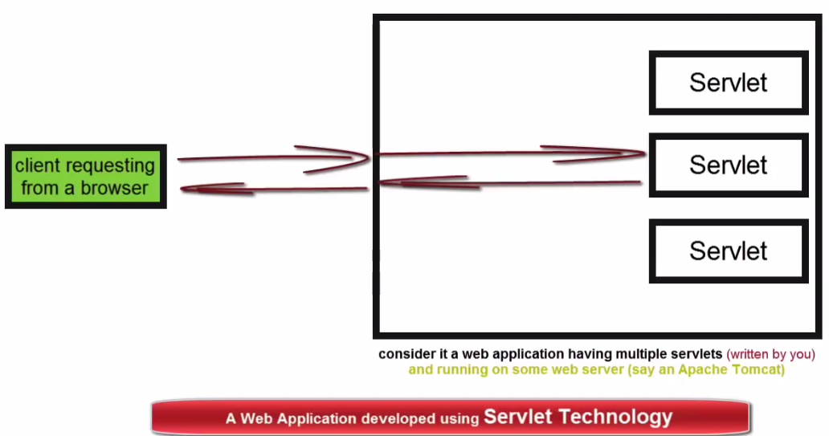

(2)In the same way a typical web application developed using JSP technology does the same thing. Here also the client requests for the web page and based on the URL the JSP page prepares the response and sends back to client browser. Many people in IT industry think that the developer who fallows these approaches, both the ways is not so appropriate. A typical JSP page or Servlet which a developers write would have two responsibility mixed together i.e. the developers should have the knowledge of both the ( UI Development + Business Logic) i.e. should have the knowledge of writing HTML Code and Java Code. So if UI developers and Business Logic developers want to work together using JSP or Servlet Technology,It would be very difficult to work independently and as a result it takes more time to be developed and apart from that if there is any change in application latter then it really a big pain. Suppose if we want to change the UI of entire web application then really it is very painful work and will require more development and testing efforts.

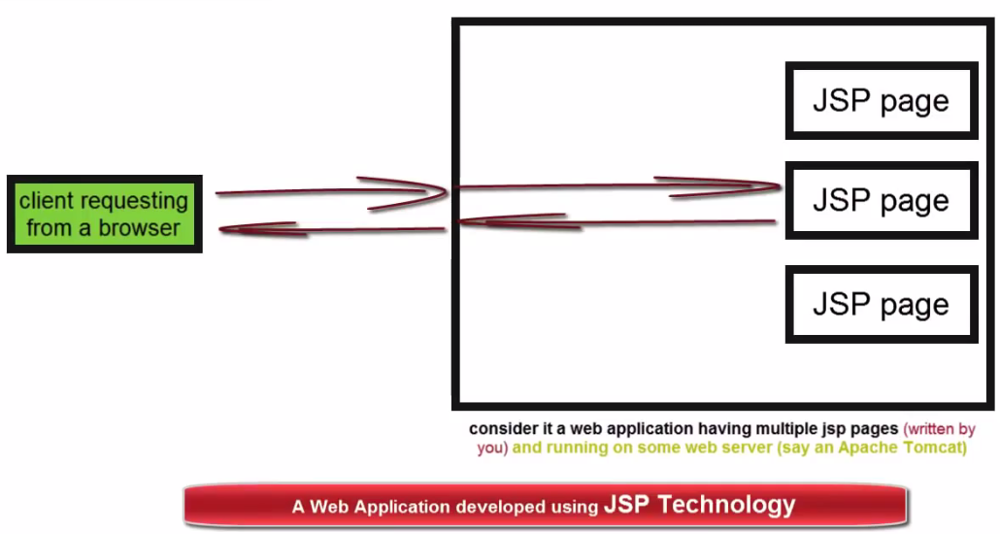

**MVC** says we can overcome all such problems to greater extents if write an application in such a way that the UI code is never written with the business logic codes as it happens with the case of Servlet and JSP.

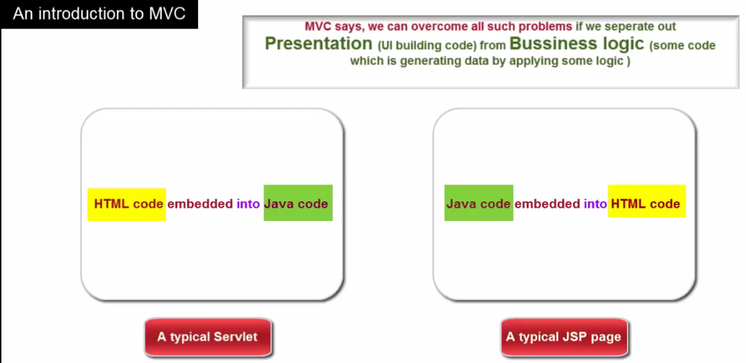

(*) The **MVC** says an application should be divided into three components that are called **MODEL,VIEW,**and **CONTROLLER** (MVC).

* The (M) MODEL represents data.
* The (V) VIEW represents the UI part.
* The (C) CONTROLLER: Manages the application flow, makes a call to some sort of services producing model, and then passes on the Model to the View. So this is this the overall flow how it is works.

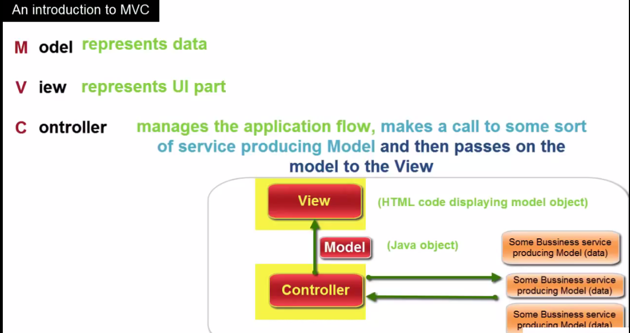

According to the diagram, Request comes to the application, the controller analyses it and makes a decision to call an appropriate business service to get the model (data) .Once it receives the model from the business service it passes on the business model to the view component . In order to form final out or response which can be sent back to the client’s browser

Let say In case we are developing a web application in java, then the model is typically is a java object having some properties along with getters and setters method and typically the view is an HTML code displaying data by retrieving it from the model object and these business service also the java object having some business logic to produce a model object.

Example of MVC

Let take an example from real life that how the overall concept of MVC works.

* Say in a cake shop we have three rooms and in each room has a different machine installed which has the capability to prepare a specific type of cake. Let’s say the machine in first room prepares the chocolate cake and the machine in the second and third room prepares the Vanilla and strawberry cake respectively.
* We have two employees who have skill set of how to decorate the cake in a specific way. Say one person is specialized in writing a greeting message on the cake in English language and can decorate it further with fruits. Other can write the greeting message in Hindi language and can decorate it further with cream.
* Now when some customer comes to the shop then we take the request from the customer and depending the type of cake the customer wants ,we delegate the request to the specific cake maker room and once the cake is ready we received it. We further pass on the cake to a specific cake decorator as per customer choice. Once the cake is ready along with desired with decoration which customer ask for we deliver it to the customer. Now the customer is happy.

This is an example where can see the MVC concept in real lice situation.

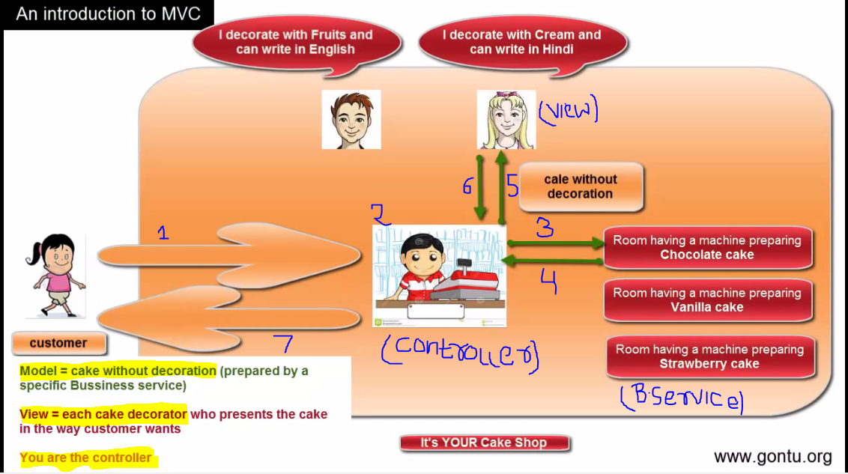

Note: There is little bit confusion in definition of MVC .Different frame work have implemented MVC concept in different ways ,different people have different perception of MVC guidelines as there is no formal definition available for MVC .It’s not the question that some is right or wrong. Only concern is business logic and presentation should be developed as a separate component which is the main aim of MVC guideline.

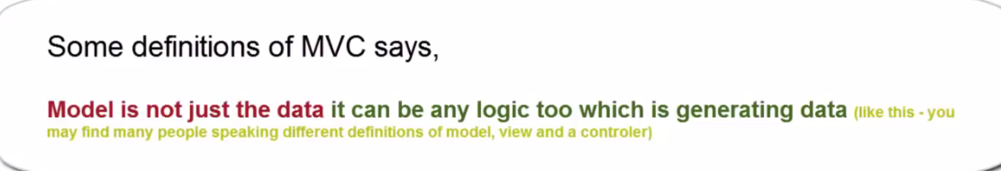

Spring MVC Framework

Spring MVC is Web Development Framework which is used to develop web application based on MVC guidelines. It is similar to any other MVC framework like JSF and Struts2 but sometime still it becomes developer’s first choice over others because it supports to a simple yet the most powerful features and that is Inversion of Control (IOC) or the dependency Injection (DI).

In Spring MVC framework there we have a controller called as**Front Controller (FC).** When an end user (Browser) request for a web page by putting some URL of browser and hits enter then the request is received by Front Controller (FC). This is the main guy who controls the complete flow of the application and has many **helpers** around it to get ----------. Each helper is going to do a certain specific task and return result back to it (FC). With the help of these helpers the FC job is to prepare and send the response i.e. HTML along with Data back to the client browser.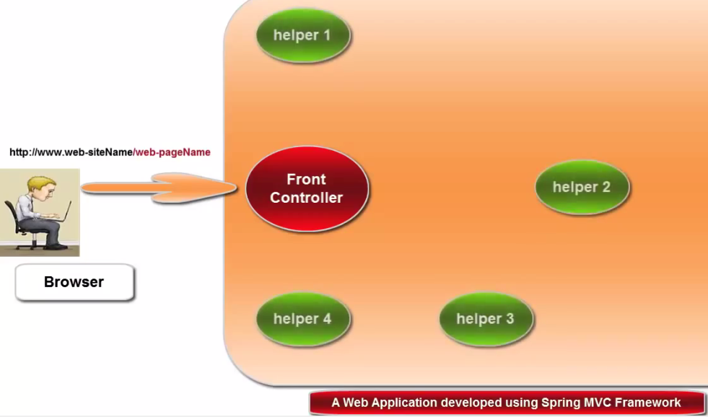

When the FC gets the request from the client (browser), immediately it passes on the request to one of its helper guy called as Handler Mapping.

**The Handler Mapping** job is to tell Front Controller (FC) what this is all about .It will simply scan the URL and tells the front controller the complete address of the guy who can generate the data for the web page which an end user has requested for . It is something similar to the situation, we are standing on the road side and someone comes to us and asks “Sir can you please tell me the exact address of the guy who sales the gift items in this area and you tell him exact address of the best item shop located in that area based on the gift item which he wants to purchase “and that what the Handler Mapping does.

Based on the information provided by the handler mapping (HM) the front controller (FC) just passes on the request to the specific guy who is going to generate the data for the specific web page request. This guy just prepares the data and typically creates the java object to hold this data. It may contain some business logic to generate data it may get data right away from the database also it may callsome other java classes to do this job. Once it prepares the java object holding data, it sends it back to the front controller (FC).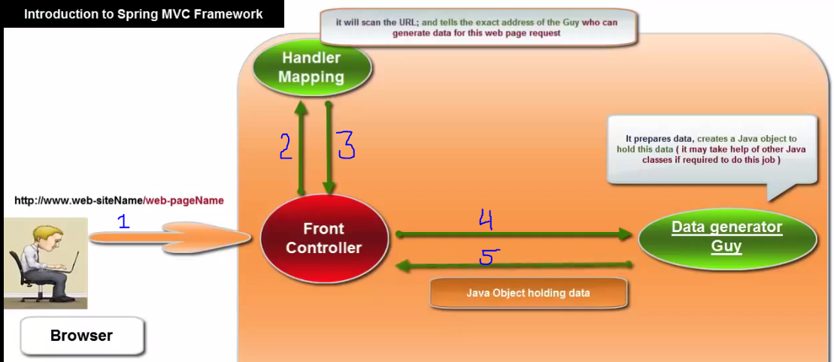

In addition to the java object holding data it sends one more things to the front controller and that is the name of the component which is going to retrieve data from this java object along with mixing it with HTML to prepare the actual response. It is something similar to the situation that the person who asked for the address of gift shop to you reaches to the shop as per your guidance the shop guy gives him just the item but does not wrap it using gift wrap (paper). While giving the item to the person the shop guy tell the name of person who can wrap the particular gift item.

Now again the person does not have the exact address of the guy who is going to wrap the gift item but yes he know the name of gift wrapper. In the same way the front controller is having a java object which is to be consumed by some component whose name is available but not the actual address where it is located in the application in order to frame the response. So now the FC sends the name to another helping guy called as **view resolver who tells the exact address of the guy to the front controller.** Now the Front controller has the java object which holding data and the exact address of the guy (View Component) who is going to generate the actual response which is to be sent to the client browser by putting up this data into an HTML code. So it sends the java object to this guy and this guy simply retrieves the data from the java object and puts it to the HTML code in the desired fashion and sends back it to the front controller. Now the front controller sends the response to the client browser and the browser happily displays it.

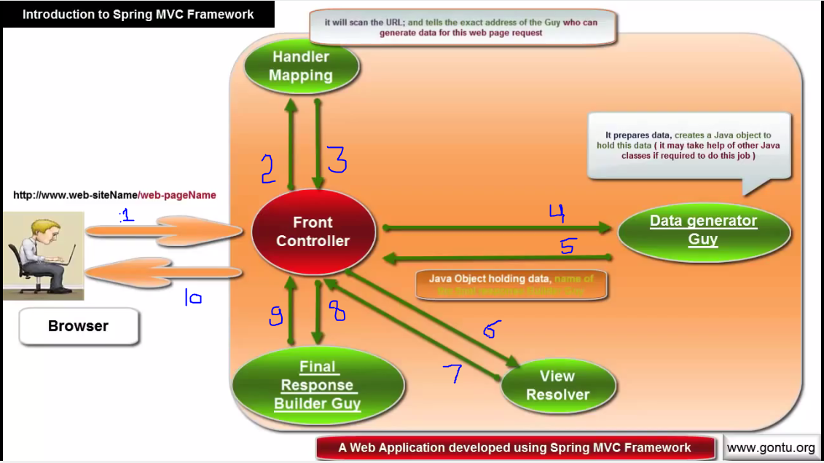

**(*)**The final response builder guy is called *Final Response Builder Guy* **(View Component)**. The view component is typically a JSP page but we may use some other popular technology like Velocity, Freemaker etc. **(*)**The guy who tells the exact address of the final response builder guy to the FCfor making final response is called as **View Resolver. (*)** The java object holding data is called as Model and the component, who prepares data, creates a java object to hold this data is called as Data Generator Guy (**Controller) i.e. the guy who returns the model object along with the name of View is called as Controller. (*)** The helper who scans the request URL and tells the exact address to the FC for preparing data (Creating java object to hold this data) is called as **Handler Mapping.**(*) The front Controller is nothing but is the dispatcher called as **Servlet dispatcher** which dispatches the request and response from/ to client and several helper guys.

The Equivalent diagram is given as below.

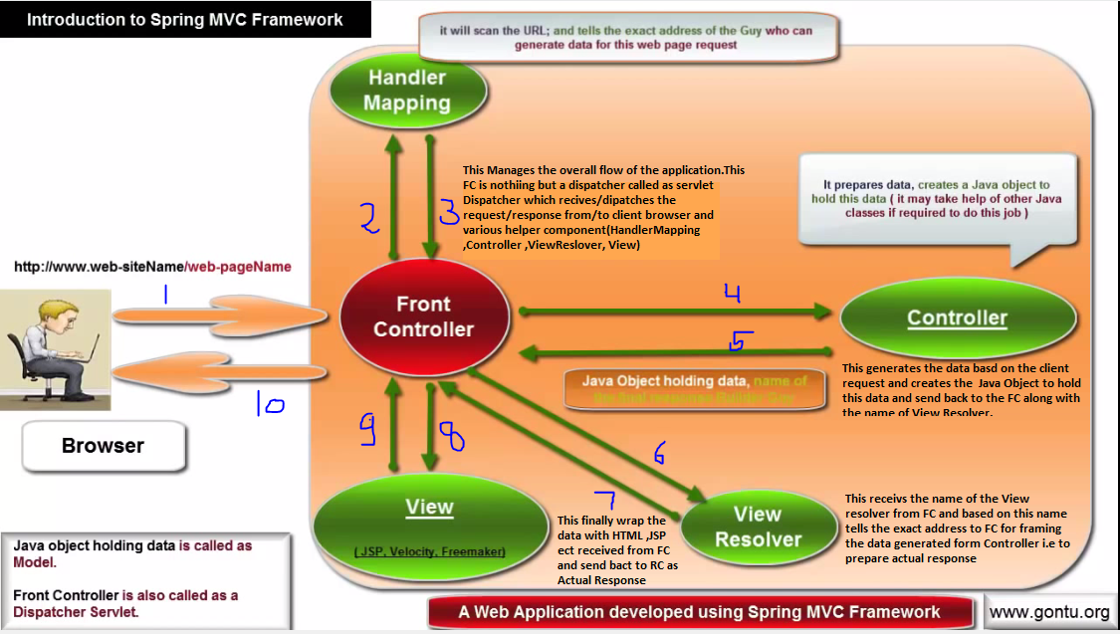

**Installation and Setup for Spring MVC framework Using Eclipse.**

Steps:

1. Open the eclipse IDE.
2. Right click on Project explorer > Select Other > Choose Dynamic Web Project >click Next.
3. Give the name of Project.
4. Select Servlet Version 3.0 if using J2EE 6 and select Servlet Version 2.5 if using J2EE 5 or below from Dynamic Web Module version.
5. Click Next > Check Generate Web.xml deployment descriptor checkbox
6. Click Finish.

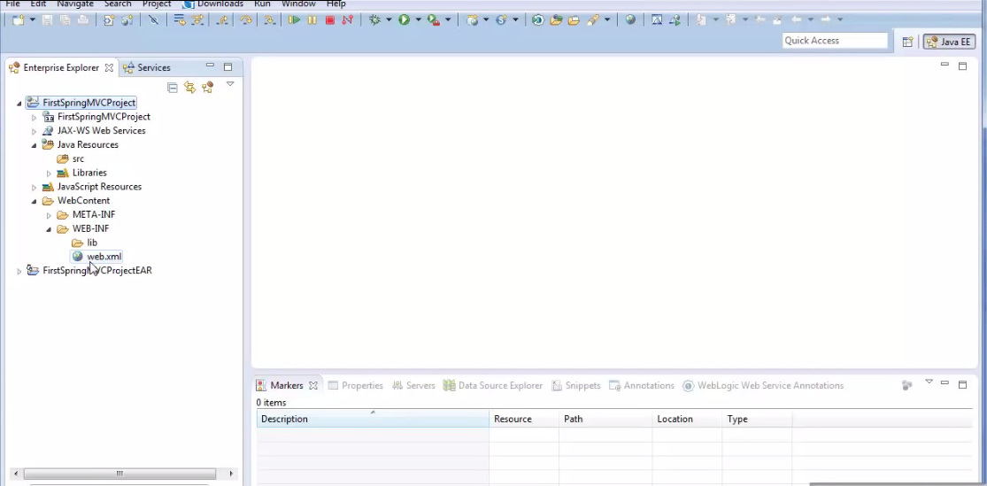

1. Download all required spring jar files from the given URL

[**http://repo.spring.io/release/org/springframework/spring/**](http://repo.spring.io/release/org/springframework/spring/)

1. Extract the jar file from the zip and paste these jar files into the lib folder of the created project.

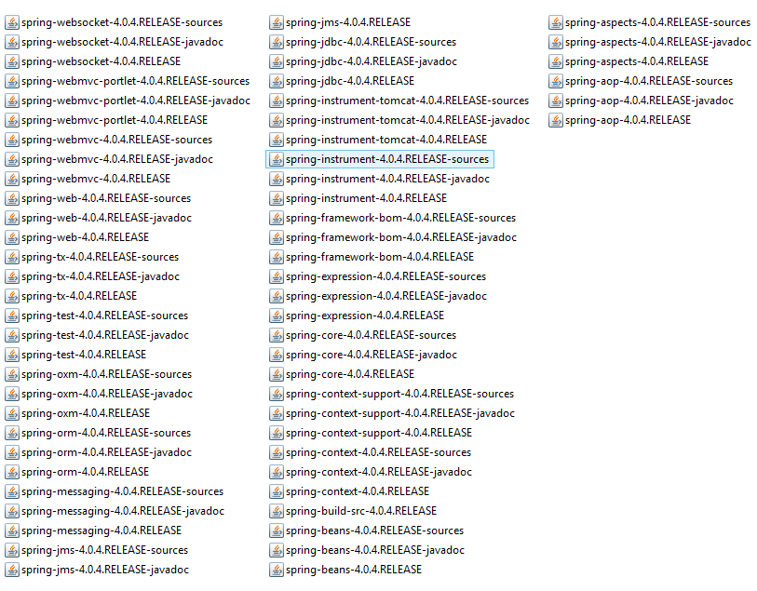

1. So this way we can include all Spring MVC related jars onto the project class path . There we have one more jar that the spring MVC framework needed and that is Commons-logging jar for logging purposes. We can download this jar from the following URL given below .
2. <http://commons.apache.org/proper/commons-logging/download_logging.cgi>.
3. Download >unzip and paste this jar file into the lib folder of the project .
4. Last but not least we need the web server .Any server supported JSP-Servlet technology would be fine for Spring MVC based project to run. For example : Apache, Tomcat Server , Weblogic , WebSphere , JBoss etc.

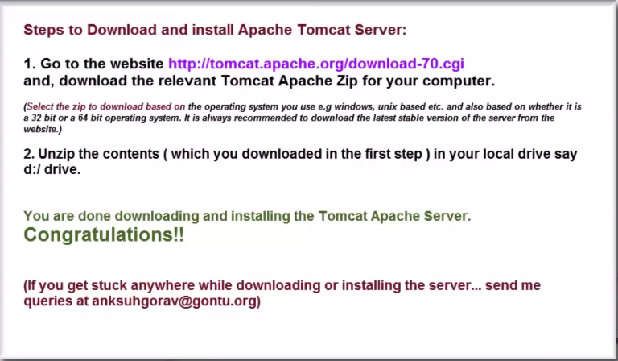

Integrating Tomcat Apache Server with an Eclipse IDE

Steps

1. Open the Eclipse IDE
2. Go to Windows >Show view >Click On Others
3. Click on Server. As soon as it is done we will get server view in the server explorer.
4. Now in the server explorer click on new server > Find the server Apache from the list > Tomcat v7.0 Server.
5. Click next.
6. Provide server installation path.
7. Click finish. As soon as finish is done Tomcat v7.0 server at localhost [stopped, Republish] begin to show.
8. Now right click on the project > Choose properties
9. Click on Targeted Runtimes > Check the checkbox for Apache Tomcat v7.0> click ok

(1)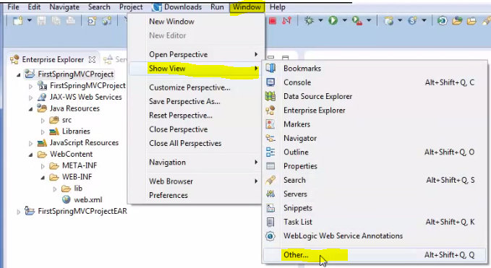

(2)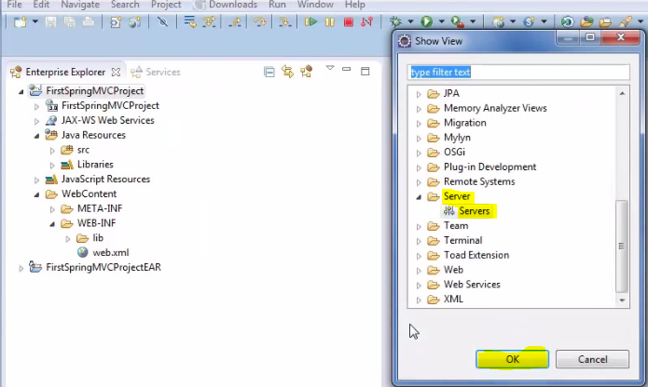(3)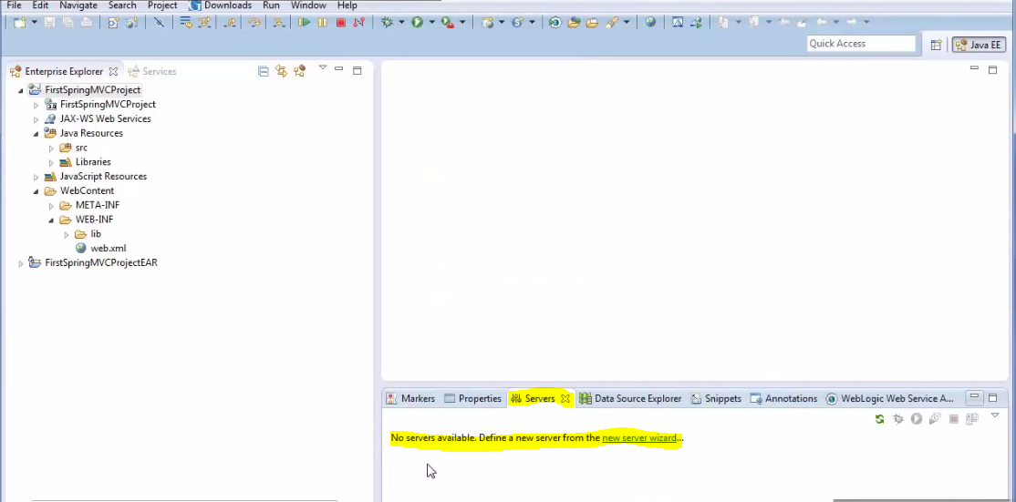(4)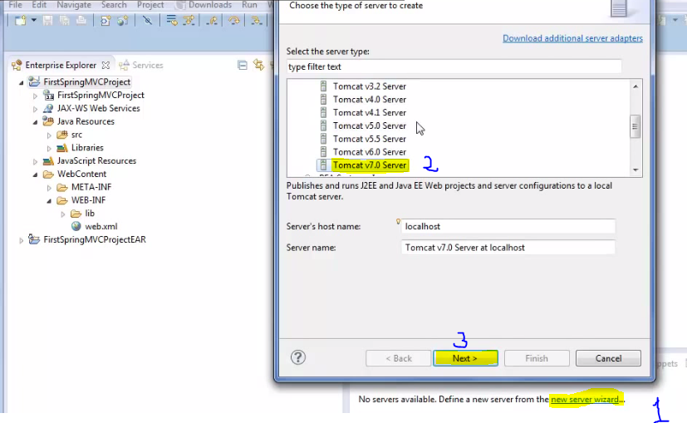(5)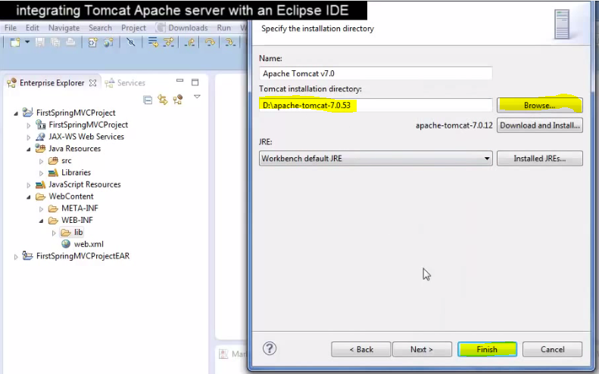

(6)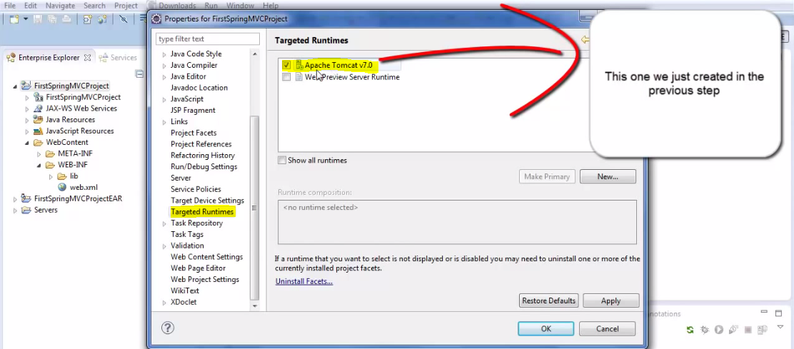

Creating First Spring MVC Project/Application Using Eclipse IDE

So far As we have already created Spring MVC project with the name of FirstSpringMVCProject. After that paste all jar files of spring framework into the lib folder of the project. Integrated the Apache Tomcat Server v7.0 server. Hence we have set all the things for creating Spring MVC project .Now do the following steps for completing a simple Spring MVC web based application. We will create the project exactly according to Spring MVC Framework flow diagram.

In this example we will cover all the things From Front Controller to 🡪 Handler Mapping to 🡪Controller to 🡪View Resolver to 🡪 Final View.

We just need to follow these 4 simple steps.

1. Modify web.xml file: (Integrating front controller here!)
2. Create spring-dispatcher-servlet.xml(
3. Create the HelloController.java class(A controller)
4. Create the HelloPage.jsp file (A View)

**(1)Modify Web.xml:** This file gets generated by default when we create any web project in java using eclipse IDE in the WEB-INF folder of the dynamic web project. In any web project we develop using Servlet technology we will always need to place a file called web.xml under WEB-INF folder of the web project. The main purpose of this file to just map the input URL request to an appropriate Servlet which can serve the request

Note: One question arises here that why I am telling all the things as we are not going to use Servlet technology and will be using Spring MVC for developing this web application. And the Answer is Spring MVC framework is actually using Servlet technology as a space. So we always need to put the web.xml file in the web project developed using spring MVC framework. And since we don’t want to write Servlet and want to use Spring MVC frame work so the default generated code into the web.xml will be replaced by as given below.

The Default code is given as below

<?xmlversion=*"1.0"*encoding=*"UTF-8"*?>

<web-appid=*"WebApp_ID"*version=*"2.5"*>

<display-name>FirstSpringMVCProject</display-name>

***<Welcome-file-list>***

***<welcome-file>index.html</welcome-file>***

***<welcome-file>index.htm</welcome-file>***

***<welcome-file>index.jsp</welcome-file>***

***<welcome-file>default.html</welcome-file>***

***<welcome-file>default.htm</welcome-file>***

***<welcome-file>default.jsp</welcome-file>***

***</welcome-file-list><web-app>***

**Since we are not going to use Servlet technology. So we will put up the following lines in the web.xml at the place of <Welcome-file-list></Welcome-file-list> as given below.**

**<?xml version=”1.0” encoding =”UTF-8”?>*<web-app id=”webApp_ID” version=3.0 xmlns=”-----“ xmlns=””>***

<display-name>FristSpringMVCProject</display-name>

<Servlet>

<Servlet-name>spring-dispatcher</Servlet-name> <Servlet-class> org.springframework.web.servlet.DispatcherServlet</Servlet-class>

</Servlet>

<Servlet-mapping>

<Servlet-name>spring-dispatcher</Servlet-name>

<url-pattern> / <url-pattern>

</Servlet-mappting>

*</web-app>*

This code is simply telling Servlet technology that all URLrequest (written between <url-pattern> tag) to the web application should be mapped to the spring MVC framework for further processing. Here in the above code we are specifically telling Servlet technology that once we receive any URL request then just map this URL request to something called as front controller also called as DispatcherServlet in spring MVC framework. After that now the front-controller will take the complete responsibility of processing the URL request and sending back the response to the client browser with the help of all its helper around it.

In order to make front-controller work and take charge of controlling the overall application we will need to provide all relevant information about application to it in a file called as **spring-dispatcher-servlet.xml**. This file resides in the same WEB-INF folder where the web.xml file is located. This is nothing but the second step i.e. creating spring-dispatcher-Servlet.xml file in the project.

**(2) Create spring-dispatcher-servlet.xml:**Let’s create this file:

Right click on WEB-INF folder >New > choose File and give it the name (spring-dispatcher-servlet.xml)

This file provides all relevant information about the application to the front-controller which the front-controller is needed to manage overall application flow. 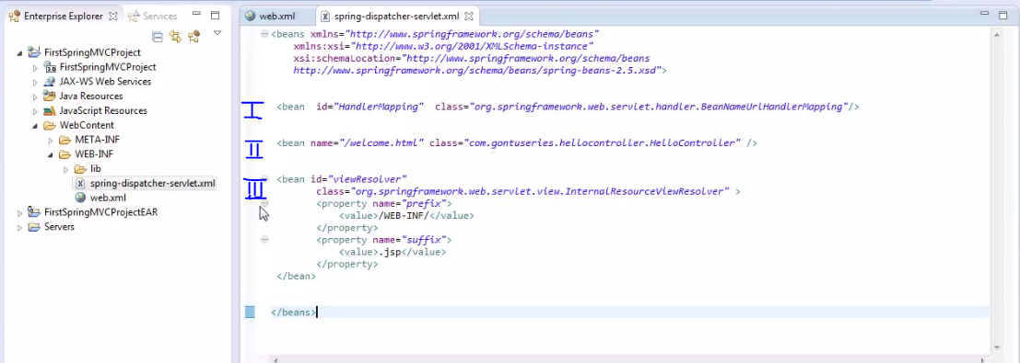

As we can see in the snap shot there we have different section (I, II, III). Each section is conveying specific information to the front controller.

**Section I**- First section tells the front controller which handler mapping to use whose job is just to scan the input URL and tell the front controller which data generating class to be called for further processing the request.

**<bean id=”HandlerMapping” class=”org.springframework.web.servlet.handler.BeanNameUrHandlerMapping”/>**

**Section II**- Second section specifies the controller of the data generating class. **<bean name=”/welcome.html” class=”com.cts.hellocontroller.HelloController”/>**

**Section III**- Third section is telling which View Resolver to use whose job is just tell the exact location of the view present in the project.

Now let us write the step 3 and 4 i.e. Controller and View

**(3) Create the HelloController.java class (A controller): (4)Create the HelloPage.jsp file (A View)**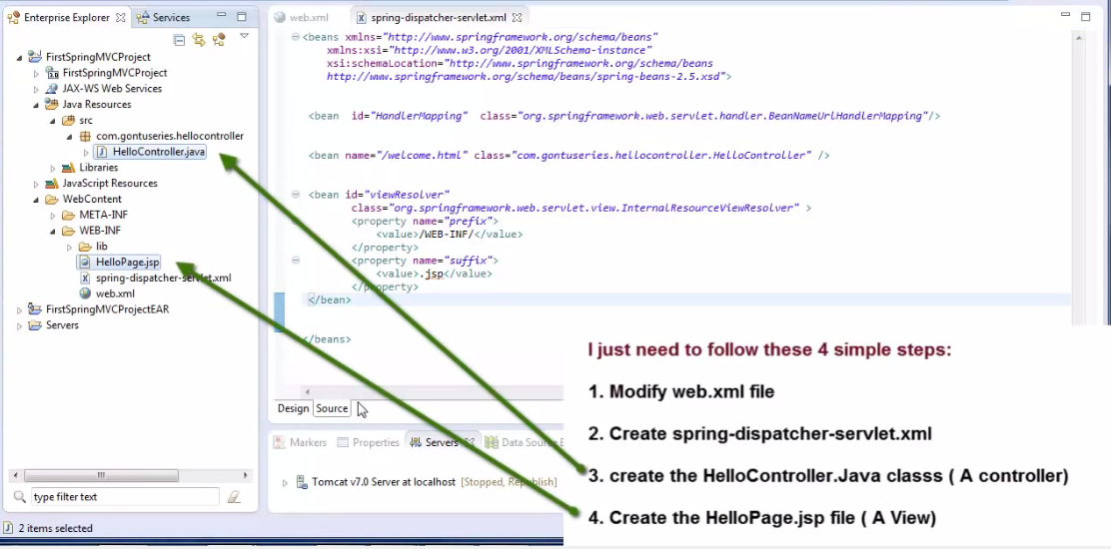

**(3)**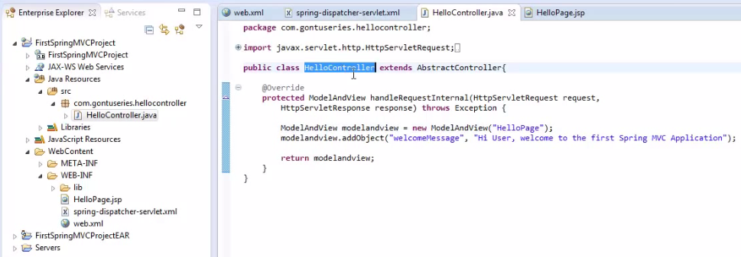

**(4)**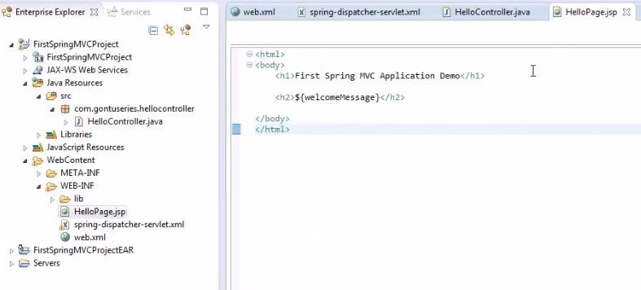

**Brief**: As in the section one, we have specified handler mapping class (**BeanNameUrHandlerMapping)** which is provided by spring framework. With the help of this Handler mapping class the front-controller find out which controller class (HelloController) has to be called for process request URL. Now the question arises that how HandlerMapping class does it. Answer: The HandlerMapping class would match the incoming request URL Pattern (<http://localhost:8080/FirstSpringMVCProject/welcom.html>) with the bean name of the controller classes which we provide here in Spring-dispatcher-servlet.xml file in section II. And once it find any beans name pattern ismatching with the incoming request URL pattern .It just suggest the front-controller to make a call to that controller class defined in that bean class . After knowing that incoming URL request pattern is exactly matching with the beans name (Section II) which is for HelloController class .Now the HandlerMapping class just suggest the front-controller to make a call to the HelloController class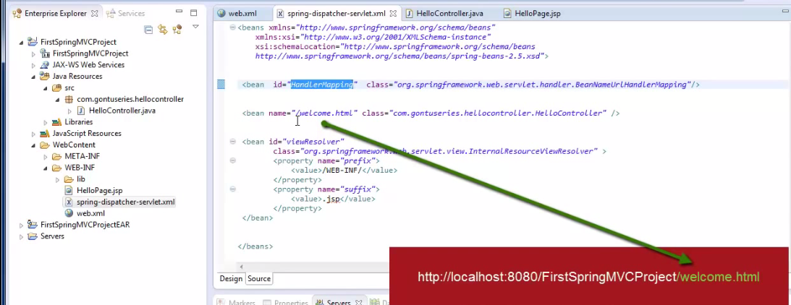

**Note**: There are many HandlerMapping classes provided by the Spring framework and here we are using the basic name **BeanNameUrlHandlerMapping**. Each HandlerMapping class analyses and matching the incoming URL request pattern using different approaches.

Now once the control reaches to the controller (**HelloController**.**java**) class .Here we have set the response in the “**welcomeMessage”** variable to be sent to the client browser and the view name (“**HelloPage**) to the **ModeAndView** object **modelandview** provided by Spring MVC framework and in the end we are returning back this object to front-controller

Note: The point to note here is each controller class has to be extended from some base controller class. Here I am extending HelloController.java controller class from AbstractController class which is the basic controller class provided by the spring MVC framework. There are many base controller classes provided by spring MVC framework

Now once the front-controller receivesthe modelandview object return by the controller (**HelloController.java**) it will need to find out the exact location of the view present in the system using the ViewResolver classes and that is what happening in section three of Spring-dispatcher-servlet.xml file. This ViewResolver class (**InternalResourceViewResolver**) will prepare the exact location of the view using prefix and suffice value which is mentioned in section three.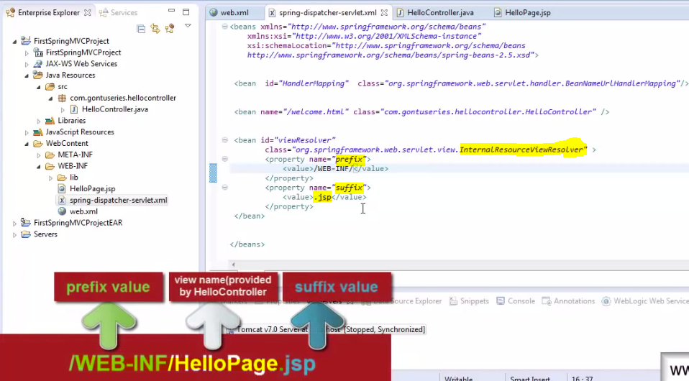

So based on the exact address provided by the **ViewResolver** class the front-controller makes a call to the **HelloPage**.**jsp**file .

Note: There are many view resolver classes provided by spring MVC framework here we have used the basic one i.e. **InternalResourceViewResolverclass .**Different View Resolver class are used for different purposes.

Now finally once the control reaches to the HelloPage.jsp, here we are simply retrieving the value of welcomeMessage variable which was set in the HelloController.java class and mixing the value of welcomeMessage variable along with the required HTML code which is to be sent back to the client browser as a response. So once HelloPage.jsp prepares the response it send back to the front-controller and the front-controller simply send it to client browser as a response.

Creating Spring MVC Project using Annotation:

Previously we have created project by following these simple 4-steps given below:

1. Modify web.xml file
2. Creating spring-dispatcher-servlet.xml
3. Create the HelloController.java class (A Controller)
4. Create the HelloPage.jsp file (A View)

We looked at each simple step in detail along with each component which we had seen in the Spring MVC workflow diagram.

Spring MVC says there are two ways of writing a controller class in our application: **(1) Without Using Annotation:** In this case we configure everything in spring-dispatcher-servlet.xml file i.e. 1- Used HandlerMapping class for scanning URL and to search controller class for processing request URL 2-Used Second section specifies the controller of the data generating class.

Spring MVC project development Using Annotation:

Spring MVC says there are two ways of writing a controller class in our application.

1. Without using annotation.
2. Using annotation.

Developing Project without Annotation: 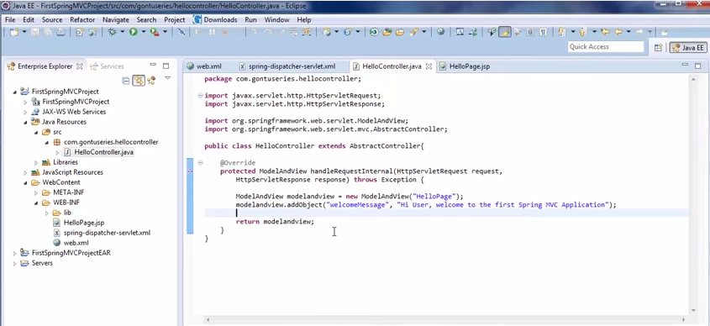

Equivalent controller class with Annotation: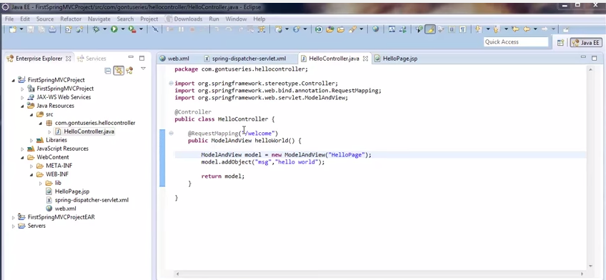

**@ Controller:**Spring MVC says if we mention **Controller**annotation on top of java class then I will consider it as a spring controller. There are two benefit of using this annotation approach.

1. We do not need to extend the HelloController class (Controller Class) from any specific base classes or implement any specific interfaces as we have did in web project without using annotation.
2. Second benefit of using this annotation on top of the controller classes is that we do not need to put its entry in spring-dispatcher-servlet.xml file i.e. we **don’t need to write following** line of configuration in the spring-distatcher-servlet.xml file.
3. **<bean name =”/welcome.html” class = “com.cts.hellocontroller.HelloController”/>**

So the Idea is that if we are writing the annotation based controller class then we don’t need to put the above entry (bean name) for HelloController Class in the xml file.

But if we are writing annotation based controller class then instead of using above line of code we will have make the entry as given below.

**<context: component-scan base-package=”com.cts.hellocontroller”/>.**

This line simply describes the spring **mvc** framework that please automatically detect all java classes having controller annotation written in then which is place in this package.

If we do not write the above scan line of code in the xml file then we will have to put an entry of every single controller class in this xml file as we did above <bean name =………/>.

So this handy feature has to be enabled when we write annotation based controller class in spring MVC framework which will make our code little bit cleaner and less number of line of code.

1. One more good thing is that we do not need to provide an entry of HandlerMapping class here in the spring-dispatcher-servlet.xml file

Hence the final structure of spring-dispatcher-servlet.xml file is given with annotation controller 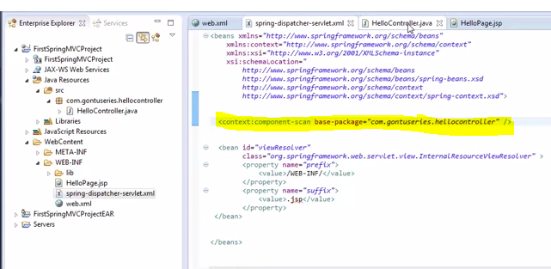

In Without Using Annotation the spring-dispatcher-servlet.xml file looking like as :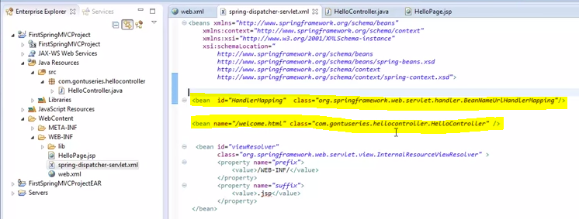

**@RequestMapping:**  This plays very important role in Spring MVC framework.When the request reaches to the web.xml file from the client browser then the request is mapped to DispatcherServlet or front-controller of Spring MVC framework.The front-controller reads the spring-dispatcher-servlet.xml file for the further processing the request. Aftr seeing the scan statement

(**<*context: component-scan* base-package=””com.cts.hellocontroller”/>) in the xml file** the front-controller understands that we have used annotation based controller in our project in the defined base-package of the project. So the first thing it does, it loads all those controller classes in its memory. Now it has to decide upon which controller method it would invoke for further processing the request. And how it does??

It looks at @**RequestMapping** annotation value of each method present in each controller class in the application and compares the values with the incoming request URL pattern and whichever @**RequestMapping** annotation value matches with incoming request URL pattern it simple makes a call to that method .As shows in the below screen.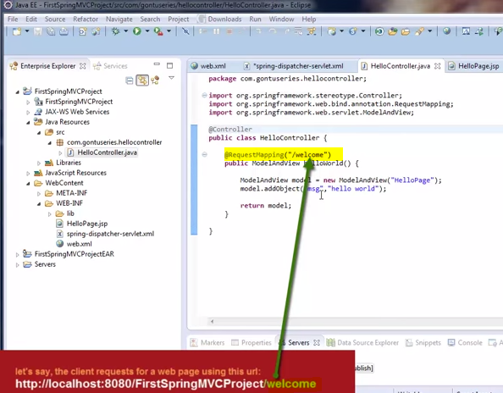

Remaining line of in controller class woks the same way as we have explained before without using annotation.i.e.

The whole method would simple prepares the ModelAndView object which having the data (hello world) stored in msg variable to be displayed on the response web page and the view name which front-controller would use is “HelloPage” . So over all -this method would send the ModelAndView object to the front controller. The front-controller now would find-out the exact path of the view in Spring-dispatcher-servlet.xml in section III (i.e. in ViewResolver class.) and this would call the HelloPage.jsp for displaying response.

**In Short:** - We have learnt that how to write a simple web application using spring annotations. Here we have learnt how to write a controller class using @Controller and @RequestMapping annotations. Here we have clearly learnt the purpose of putting @RequestMapping annotation on top of method which is residing in a controller class. The Idea is very simple and clear if we want to invoke the method having @RequestMapping annotation by the front-controller (spring-dispatcher-servlet.xml) when a client enters the URL on the browser then RequestMapping pattern **(/welcome)** has to match with incoming request URL pattern . If the incoming URL request pattern is something like as (<http://localhost:8080/FirstSpringMVCProject/welcome>) then the front-controller (spring-dispatcher-servlet.xml) would invoke the method for further processing the request only after finding that the @RequestMapping pattern of this method is matching up with the incoming request URL pattern. The method which we write in the controller class for the purpose of handling incoming request called in general as RequestHandler method by spring MVC framework.

Note: What happens if I put one more RequestHandler method in the same controller class with the name hiWorld() and with the @RequestMapping pattern like (/hi) as shown in the highlighted image .

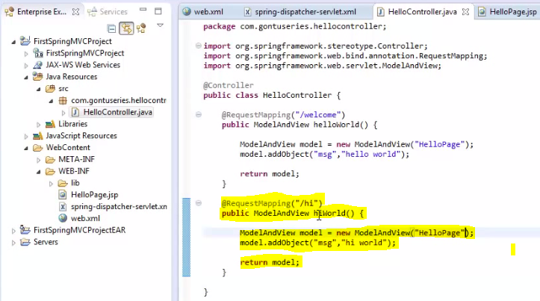So nothing special, it is just a concept in Spring MVC framework that we can write as many RequestHandler methods in one controller class as we like. So in this case if the client type the following URL (<http://localhost:8080/FirstSpringMVCProject/welcome>) then the front-controller would call the first method having the pattern (/welcome) for processing the request and if the client types the URL (<http://localhost:8080/FirstSpringMVCProject/hi>) then the front-controller would call the second method having the pattern (/hi) for processing the request. Hence it simply means that it would just match up the @RequestMapping pattern with the incoming request URL pattern and makes the call to the corresponding method. Any controller class having more than one RequestHandler method in it called as **multi action controller class.** In other word a multi action controller class is nothing but having more than one RequestHandler method in it.

Note2: What if type the following request URL pattern (<http://localhost:8080/FirstSpringMVCProject/abcdefgh>) which doesn’t match up with any @RequestMapping pattern of each method. In this case the application will return a response back to the client browser saying that there is no resource available on the server which can process this request. We get the following result “The request resource is not available”.

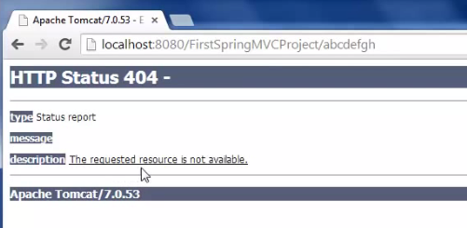

Note3:- There is a provision in the spring MVC framework the we can put the @RequestMapping annotation on top of class level also.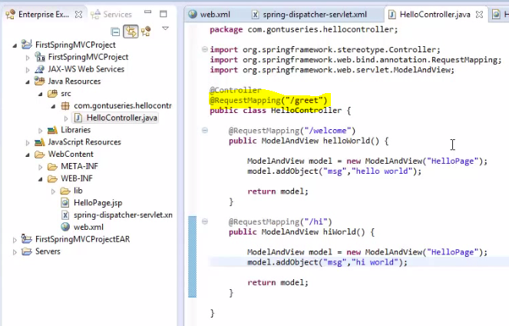

When we declare the @RequestMapping annotation at the class level then it means that there is something known as relative an absolute path in the programming world.

Earlier when we used to type the following URL (<http://localhost:8080/FirstSpringMVCProject/welcome>) then the front-controller used to make the call the matched up @RequestMapping(/welcome) pattern and for calling second method we used to type (<http://localhost:8080/FirstSpringMVCProject/hi>). But now after declaring the @RequestMapping at the class level if we type the above any one of the URL again on the browser then the front-controller would not be able to process the request and it would send back that the resource is not available to process these request. And the reason is we have declared the @RequestMapping at the class level. Now in this case the @RequestMapping annotation which we have mentioned here on top of the method are relative to the @RequestMapping annotation mentioned at the class level . It means that if we want to call method first having pattern (/welcome) for a URL request then the URL request should look like as given (<http://localhost:8080/FirstSpringMVCProject/greet/welcome>)and if we want to make a call of second method then the URL request should look like that (<http://localhost:8080/FirstSpringMVCProject/greet/hi>) .

Hence this means that the @RequestMapping annotation pattern mentioned at the method level would come after the @RequestMapping annotation pattern mentioned at the class level.

@PathVariable Annotation in Detail:

So far we have learnt that how to use @RequestMapping annotation at a method level and a class level in the controller class.

Now let’s proceeds towards another concept of Spring MVC framework. Previously when we enter the URL request **(**[**http://localhost:8080/FirstSpringMVCProject/greet/welcome**](http://localhost:8080/FirstSpringMVCProject/greet/welcome)**)** and **(**[**http://localhost:8080/FirstSpringMVCProject/greet/hi**](http://localhost:8080/FirstSpringMVCProject/greet/hi)**) then** it were but oblivious that the front-controller calls the particular method on the basis of matched up RM pattern and URL request pattern for processing the request.

Now if I make small change in @RequestMapping (“/welcome”) like @RequestMapping (“/welcome/countryName/username”) and now if I enters the same URL request as written above then the front-controller would not be able to call the methods and in response “No resource is available on the server “ as a result because the patterns are different. The front-controller now only be able to call to the method if the incoming request URL looks like this (<http://localhost:8080/FirstSpringMVCProject/welcome/countryName/userName>) The Result is given by: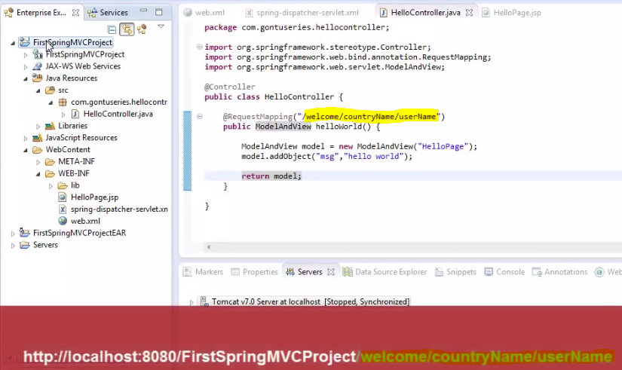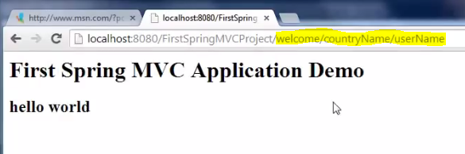

**Note1**: Now let’s modify the above **URL** (<http://localhost:8080/FirstSpringMVCProject/welcome/countryName/userName>) such that I will enter the value of userName instead of hardcoded userName string. Let’s replace userName string with value (gontu1) i.e. (<http://localhost:8080/FirstSpringMVCProject/welcome/countryName/Arun>) and now if make request URL as it is then it is but obvious that we will get “Resource is not available to process the request” as the pattern did not matched up. Now what if I want to make a request with this URL only i.e. by giving the value of userName as **gontu1** instead of hardcoded userName string in the URL path and same time I would like to want front-controller to invoke the method(1) for processing the request. So question arises how would we do that?

Ans: The answer is using curly braces {} .If we put curly braces here on the userName string then the end user is allowed to substitute this value of userName with any other value.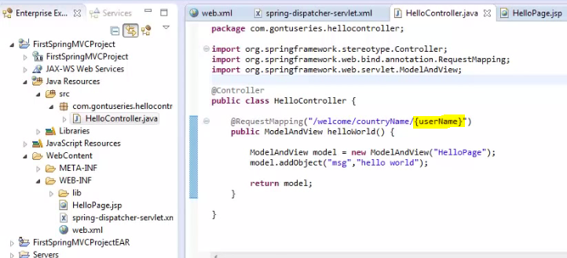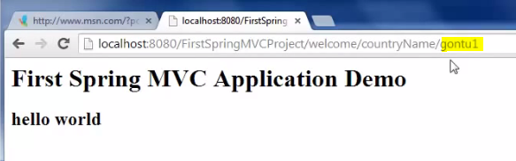

Hence the front-controller is now able to invoke the method and we are getting the desired result. Hence by putting the {} we can make the URL dynamic.

**Note2:**What if in this method I would like to retrieve the value of userName which is coming in the incoming request URL. How would we do that ?

Ans: The answer is using @PathVariable annotation 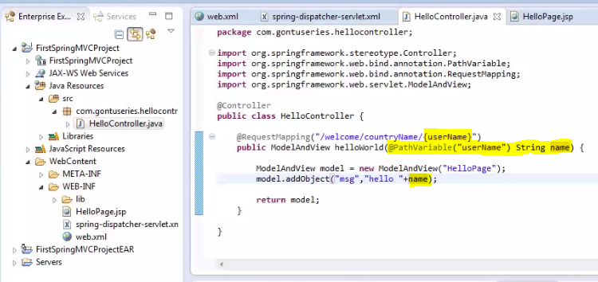

So Here with this annotation what we are telling to spring framework that, when the front-controller would invoke this method(1) then please bind the userName value which is coming from the incoming request URL with this String name variable and further we will use this String name variable which is having the userName value to be displayed. Now when we run the request URL with desired userName value then we get the expected result.

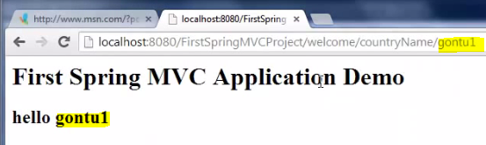

**Note3**: What I want to do the same thing with the countryName here as I did with userName. i.e. the client would provide the countryName value instead of providing hardcoded as countryName string variable in addition to userName value in the request URL. So the Answer is...................... 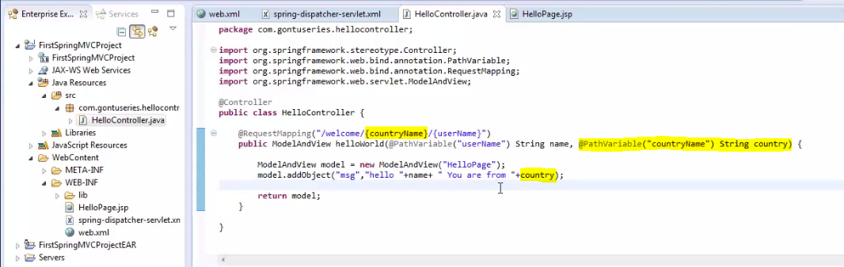

Here put the **countryName** into the {countryName} and put one more **@PathVariable (“countryName”) String country) annotation** in the ModelAndView method and return this **country** variable which is having the value of countryName variable. Here we are getting both value just because of **@PathVariable**annotation.

..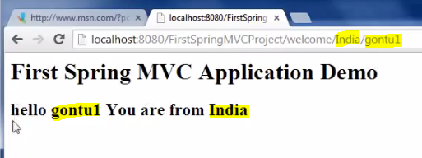

**Note4:**If we tide of putting many @PathVariable annotationsin the method argument as we have done above. So it would be very-2 lengthy. So spring says we can reduce the many **@PathVariable**annotation by putting the **@PathVariable annotation in a Map.**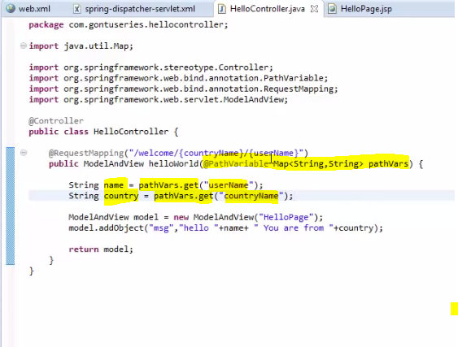

Here we have used Map and retrieve the Map variable value by simple putting userName, countryName as keys into the String variable (name and country) as given above.

One very important to know about this @PathVariable annotation when we use it on a Map then we have to define **<mvc:annotation-driven>** tag in the spring-dispatcher-servlet.xml i.e. in the front-controller. 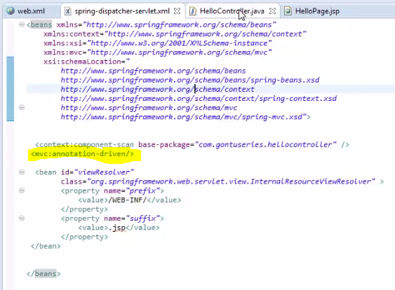

**Handling an HTML form using @RequestParam Annotation**

Previously we have learnt about @PathVariable annotation. It is used for accepting (or binding) the customized or dynamic parameters coming from the request URL with the defined String variable into the @PathVariable annotation.

Now we will learn about @RequestParam annotation and along with it we will learn how to write and handle an HTML from in a spring MVC application. Please fallow the following steps given below.

1. Creating a StudentAdmissionController.java class.
2. Creating AdmissionForm.jsp
3. And AdmissionSuccess.jsp.

1Creating a StudentAdmissionController.java 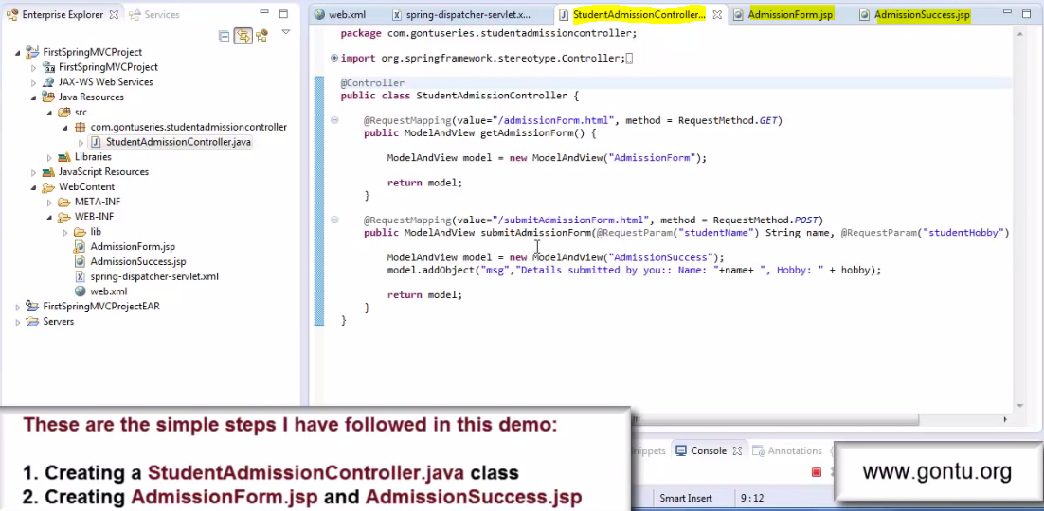

2-AdmissionForm.jsp 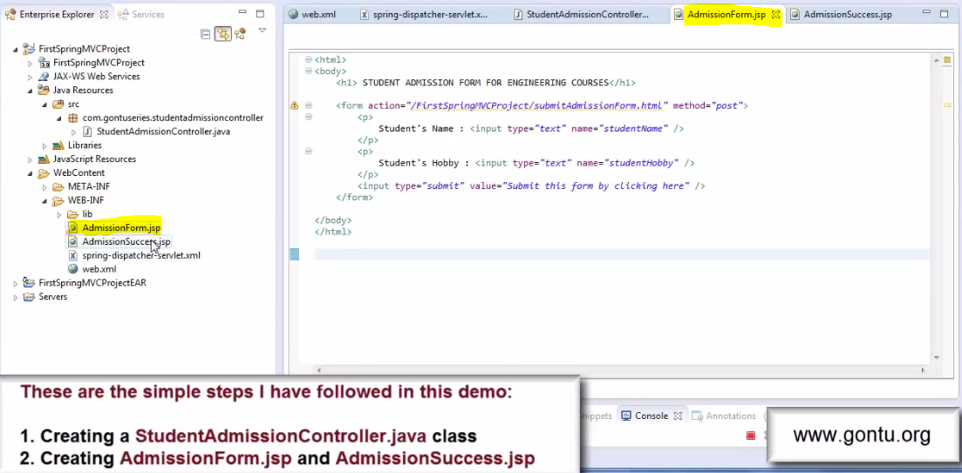

3-AdmissionSuccess.jsp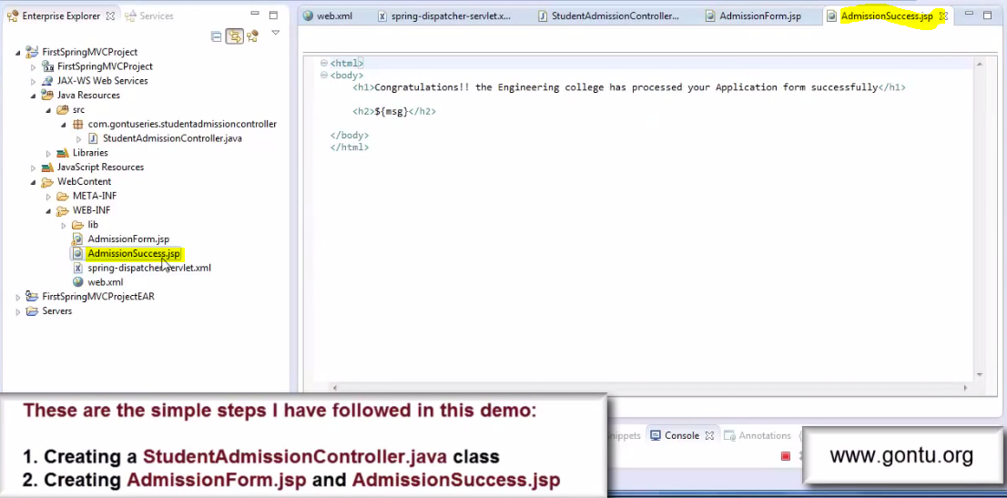

4-Result after running

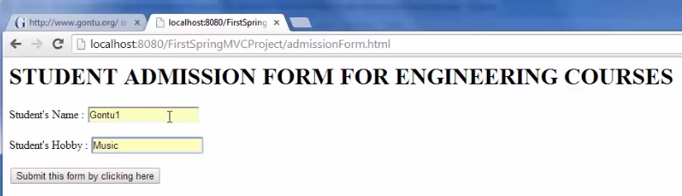

5- Result after submitting the form.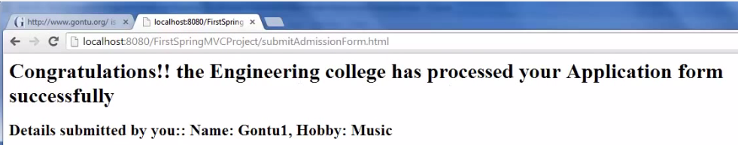

**Explanation**: Here when we run this application on the server the client will enter the URL(<http://localhost:8080/FirstSpringMVCProject/admissionform.html>) on the browser and hit enter then we get step 4 as a result .Now client will fill up the required value (Name and Hobby) and click on submit button and finally we get the step5 as a result.

**StudentAdmissionController.java:**  When the client the request the URL (<http://localhost:8080/FirstSpringMVCProject/admissionform.html>) and hits enter then the request reach to application and here in the application the front-controller (spring-dispatcher-servlet.xml) will make a call to method1 (getAdmissionForm()) right away by matching up two things defined in the @RequestMapping annotation.

1. By Pattern :i.e. value= “/admissionform.html” (As we have learnt previously)
2. Second things are (method=RequestMethod.get): This is nothing but the http request which client had made. So here when client makes a request using following URL, then that request can be of get, post or can be of other http request type. So when we write statement (method=RequestMethod.get) on the top of method then it simply means that this method can process only the request which is of type get. When client enters the above URL on the browser, the browser by default makes the get request to the server. When the request reach to the application ,the front-controller of the application would make call to this method1 state away after matching the URL pattern with the RequestMapping value pattern and also the type of method request this method accept is matching up with the type of request which client had send. So here in this method the RequestMethod is get type and request send by the client is also get type so this method gets called.
3. Now this method simply returning ModeAndView object having view detail back to front-controller. The front-controller would then state away forward the request to the AdmissionForm.jsp file with the help of view resolver class using prefix and suffix statement. Now once the control reaches to the AdmissionForm.jsp file it prepares the response using HTML code written into AdmissionForm.jsp file.



It contains simple html code having two fields (Name and Hobby) and submit button. The point to note here is the method argument is post in the <form> tag. So when client submit this form on the browser ,the request type which would reach here is post request.

(*)After processing the request, this jsp now would send the response to the front-controller and front-controller in turn would send this HTML form back to the client browser and form will see like given below.



(*) Now here we would enter all required value (Name and Hobby) and will click on submit button. Once we click this button the request would again reach to the application (StudentAdmissionController.java class) with the URL (<http://localhost:8080/FirstSpringMVCProject/submitAdmissionForm.html>) and request type POST.

How: - By simply because of the POST method which used in the form and the URL for this action attribute of the <form> tag.

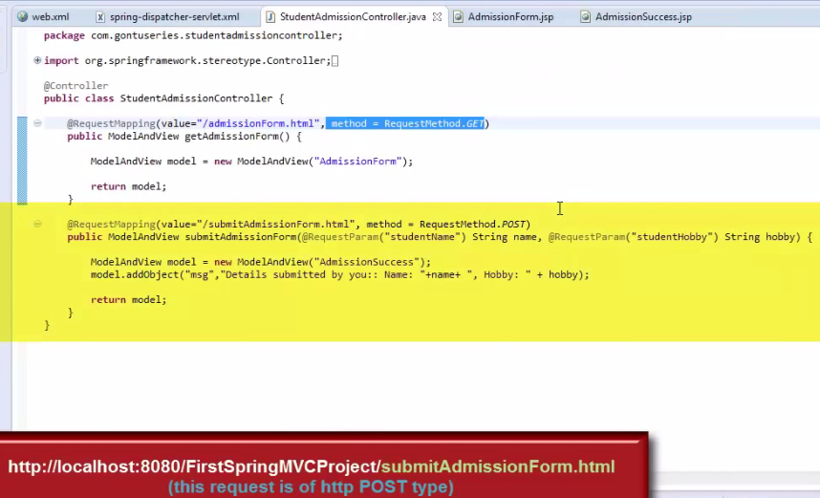

(*) Again now the front-controller state away would make a call to method 2 (submitAdmissionForm()) after matching the pattern of this method with incoming URL pattern as well as the method type for this method is matching up with this request Post.

**Note:- @RequestParam:-** When client submit AdmissionForm.jsp form on the browser then it will send the values of these two request parameter (studentName and studentHobby) to this application along with the request POST. Now when the front-controller makes a call to the method2(submitAdmissonFom()) then the @RequestParam annotation used in the method would simply retrieve the value of studentName and studentHobby request parameter from the request in this method body. Here the @RequestParam annotation would simply bind the value of studentName with the (String name) variable and the value studentHobby with the (String hobby) variable in the method.

Now this method simply returning the ModelAndView object back to the front-controller having the view detail “AdmissionSuccess” and the message which has to be printed in the response Web page . So once it prepares and sends the ModelAndView object to the front-controller, now the front-controller would farword the request to the AdmissioSuccess.jsp file with the help of view resolver class.

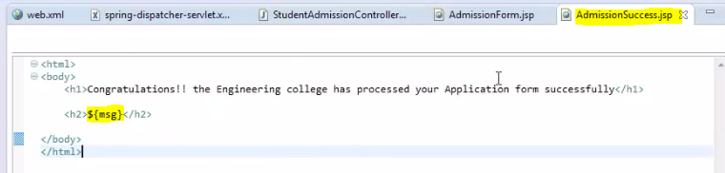This file simply putting the msg value which has already set in the method2. Now after processing the request by this jsp the response again send back to the front-controller and front-controller in-turn send response back to client browser and finally we get the final response as given below.



Note(Providing default Value):-So when a client submits this form by putting the value (Gontu1 and Music) then we get the above response. Les say if we did not any value in the Name text box then obviously the name filed value would not be displayed in the final response and we get the response like given below.

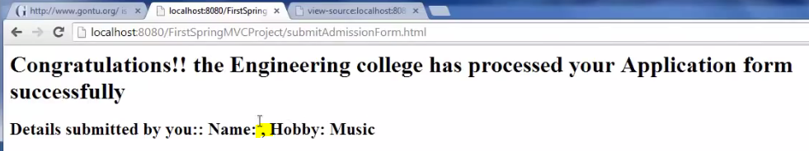

Here the name field value is blank and Hobby value(Music) is coming.

So in this case if we want to set any default value then for providing the value as default we need to do as given below.

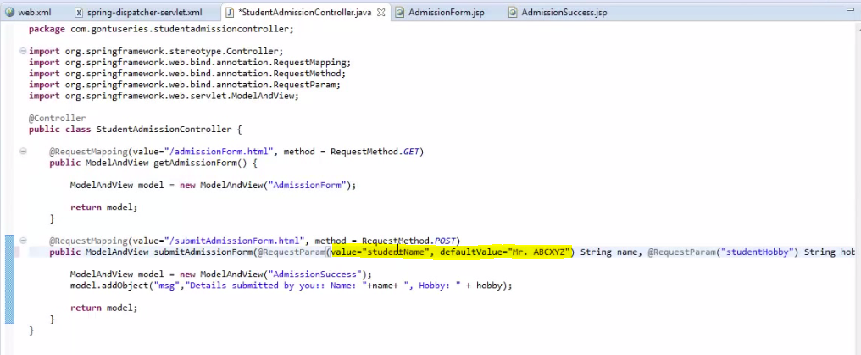

Here we have used the syntax @RequestParam(value=”studentName”, defaultValue=”Mr. ABCXYZ”). Here we have used defaultValue property for providing the default value. So in this case if we don’t put the value in the name filed then in this condition its defaultValue gets printed .Like as given below.

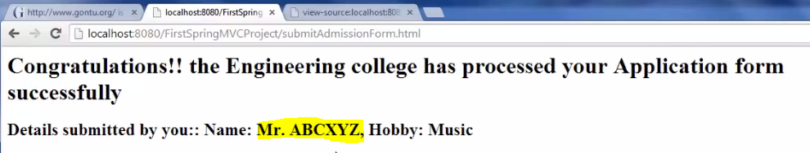

**Note: Using Map in the @RequestParam annotation:**

Q-What if we tired of putting so many @RequestParam annotations here in the method argument to retrieve all values of request parameters coming along with the request?

Ans:- So to avoid these too many @RequestParam annotations in the method argument and to use only one @RequestParam annotations on a Map as we have seen previously with the @PathVariable annotation.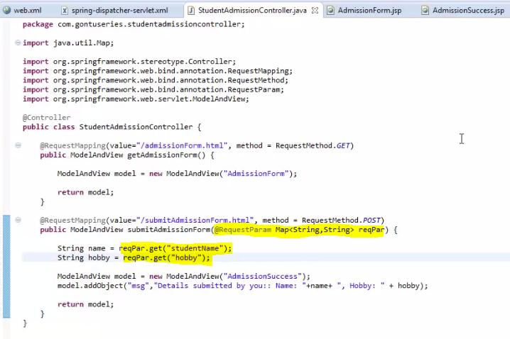

Here we have put the RequestParam variable in the Map and latter retrieve the parameter value by using parameter defined in the jsp as keys.

Using @ModelAttribute Annotation

Previously we have learnt about @RequestParam and have learnt how to use it in the method argument and at the method level in a controller class. It is used to bind the request value given by the client to the String variable defined in the @RequestParam annotation. Now we are going to learn one more important annotation used in spring mvc framework @ModelAttribute. We can use this annotation on a method and in method argument as well.

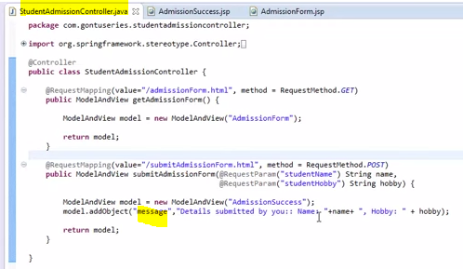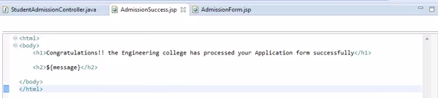

As here from above images we can see that in the second Request handler method we are setting the value with string object ”message” and again we are displaying the set value in the controller on the JSP page by using the string object “message” as we can see n AdmissionSuccess.jsp. So this is the wonderful feature provided by spring mvc framework to display the message on the jsp. So the Idea is very clear if I am creating some object the ReqestHandler method and I want to access that object in the Jsp file then what I need to do, I would simply need to add that object to the ModelAndView Object using its addObject method and after that simply access that object in the jsp file by simply its name (like message).

Let’s create one more Student.java class .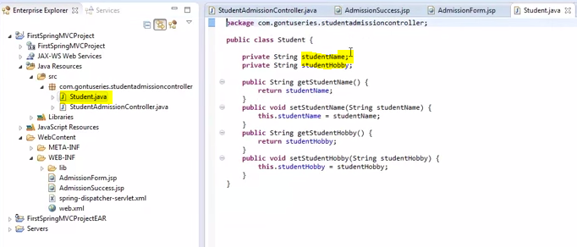

This class consists of two property studentName ,studentHobby and its getter and setter method as shown in the image.

Let’s do some change in second Request handler method of controller class and do some change in AdmissionSuccess.jsp file.

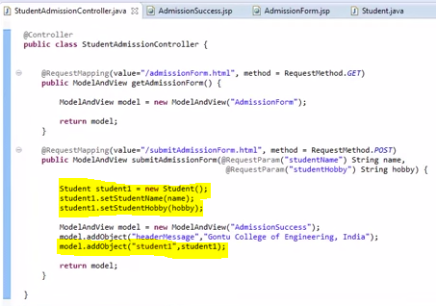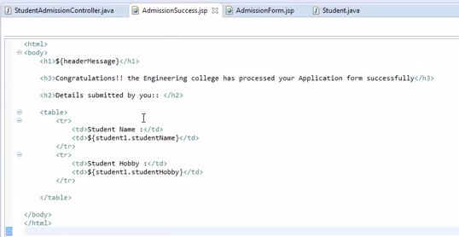

Here in the second Request handler method of controller class we have created Student class object and set the name and hobby from RquestParam String variable and finally add this Student class object with ModelAndView object using addObject method.

In the AdmissionSuccess.jsp file we are just retrieving ModelAndView object as shown in the image.

Now run this application and see the result.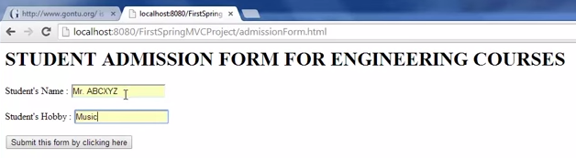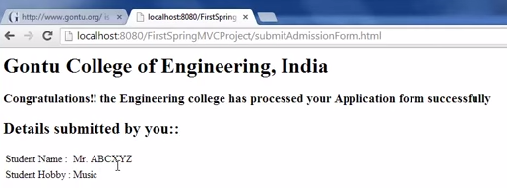

So we are getting the desired result as expected.

So here we have two important things to understand:

1. First we are writing code for binding the Request parameter value with the corresponding properties of user defined object student1.
2. Second we are adding the user-defined object student1 to the ModelAndView object model with the help of addObject method.

Spring MVC says this the right way of doing things for a requirement like above but we have and option to do it by writing less code and do more things with the help of @ModelAttribute annotation. Let me explain what I am talking about.

-In the above handler class we are forcing to extract request parameter using @RequestParam annotation then creating student object and -then binding request parameter values with the properties of student object and -then including student object with ModelAndView object.

So lots of steps are involved here

Spring MVC says if we replace @RequestParam annotation @ModelAttribute annotation i.e.

Replace (@RequestParam(“studentName) String name, @RequestParam(“studentHobby”) String hobby) with as (@ModelAttribute(“student1”) Student student1) then we don’t need to write below code.

Student student1 = new Student (); student1.setStudentname (name); student1.setStudentHobby(hobby);

And also don’t need to add student1 object with ModelAndView object. So finally we will have code like as below.

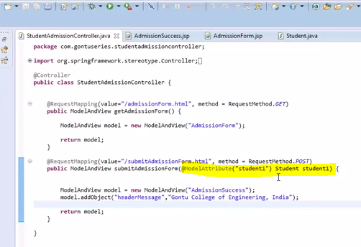

Hence we just need to write @ModelAttribute annotation on Student Class object and then (1)We don’t need to write the explicitly code for binding request parameters to the Student Class properties objects and (2) also we don’t need to add explicitly Student class object with ModeAndView object.

And now if I run the application then will get the same result as we get previously without using MA Anno.

If we don’t want to use @ModelAttribute annotation then we need to write the code explicitly i.e. then (1) We need to write the code explicitly for binding request parameters to the Model class properties object (2) We need the add Model class object with ModelAndView object explicitly.

**Important Note:** When use the @ModelAttribute annotation on Model (Student Class) object then to extract all request parameter and then bind all request parameter with the corresponding properties of Student class (Model class) object . When we say the corresponding properties of Student class object then it means Spring MVC would maps the name request parameter (studentName)ofAdmissionForm.jsp with Student Class property i.e. with studentName. Similarly name request parameter (studentHobby) of AdmissionForm.jsp with Student Class property studentHobby.

So in short we can say that Model Class (Student Class) property name and JSP form request parameter name should be same. 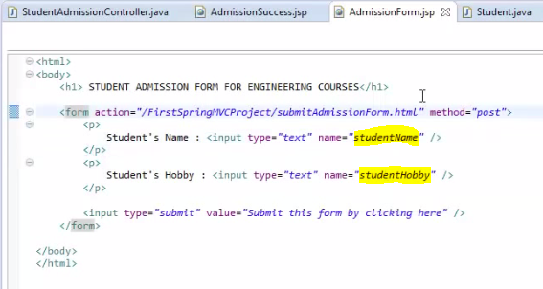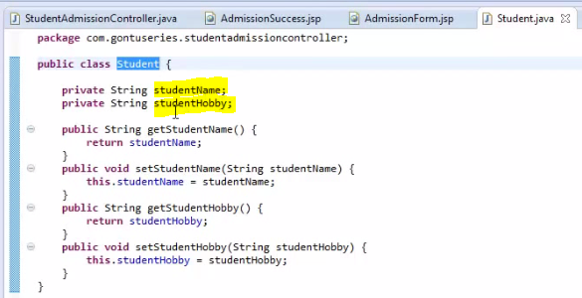

Here the JSP file request parameter and Student Class properties are same.

Using @ModelAttribute Annotation At Method Level:

We have learnt that how to use @ModelAttribute annotation in the method argument .Here we have learnt that how this annotation help in binding the Model class property to the request parameter of JSP file in a very less code just by simply using this annotation on Model Class Student. 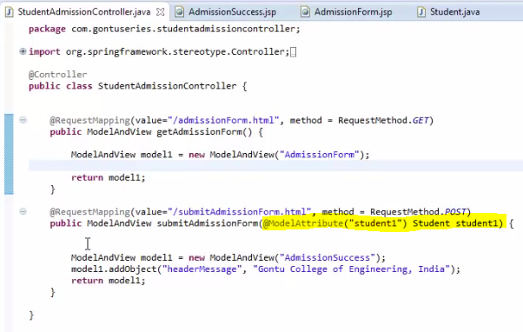

Now we will learn to use same annotation at method level. Before start let’s do some changes in the above image file and 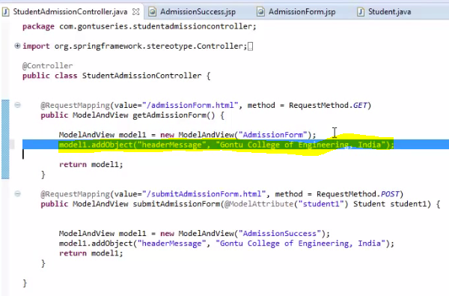

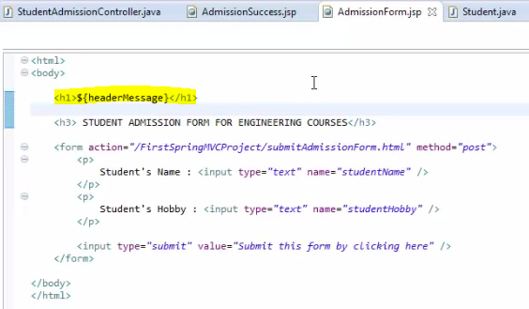

We have just added one headerMessage on the top of the JSP page and in the controller class we have added one more ModelAndView object and in that we have just added one statement in the string object “headerMessage” use this object on the JSP page to show the statement added in this variable .Now if run this Jsp page then this headerMessage would be printed on the top the page as shown in the below image.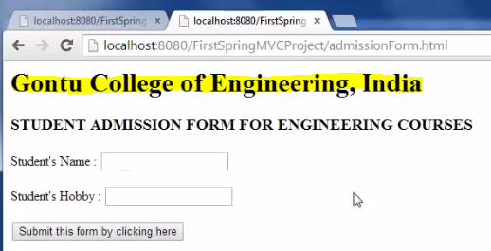

So yes we are getting the result as expected.

Now after getting this response if we carefully observe the controller class the we would find the in the controller class we have two handler method and in both the method there have a common line of statement i.e. same kind of object in both the handler method i.e. “headerMessage” string object.

Spring MVC says if we have requirement like this where all request handler method which are present in the same controller class are putting or adding same kind of object in their respective ModelAndView object then this is the right way of doing things and there is no doubt about it.

But if we have another option with less code and do more using @ModelAttribute annotation on a method. Let’s understand by the following image given below.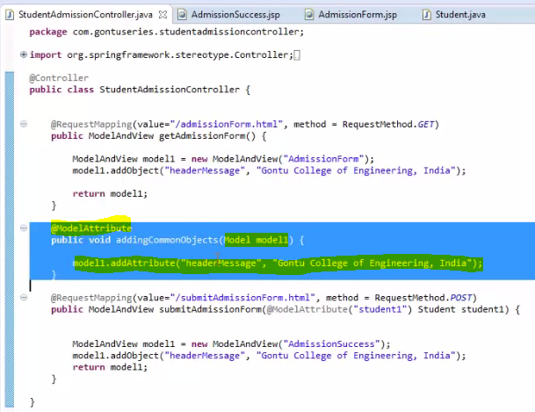

Spring MVC says if add the method like give above in the controller class where @ModelAttribute is present on the top of the method (method level) then whatever object(“headerMessage”) is added to its model object (model1) ,Spring MVC would automatically add that object (“headerMessage “) to the ModelAndView object for each Request handler method present in the controller class.

In simple word if we say after adding this method where @ModelAttribute annotation is declared at method level and putting or adding any object to the ModelAndView object then we don’t need to write that added object in each and every request handler method present in the controller class i.e. it simply works as common statement for all the handler method present in the same controller class.

Important Note: Whenever controller class having a method like this i.e. method having ModelAttribute annotation on the method level then Spring MVC framework would always make a call first to that method before making a call any of its handler method present in the same controller class.